http://www.tel-test.com/services.htm#9

IF greater than 2.1 - your RNA has been degraded(降解), probably due to prolonged（延长） exposure（曝光） to the extraction（抽提） reagent（反应物）.

xx

www.diagenode.com/.../RNA_Extraction_from_Tissue_with_Bioruptor_ Standard_Plus_protocol.pdf

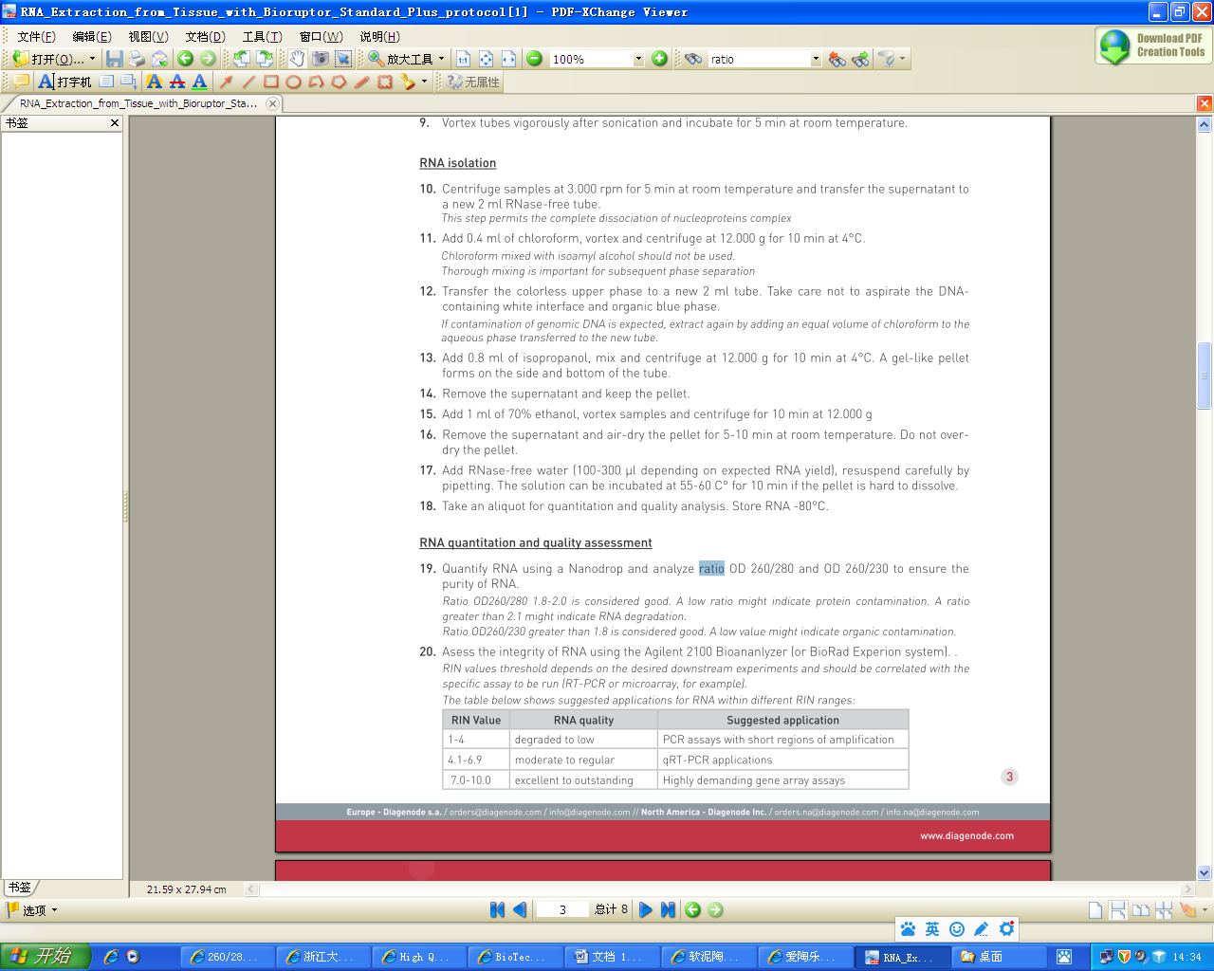

xx

http://molecularbiology.forums.biotechniques.com/viewtopic.php?t=19137

by [**smileface**](http://molecularbiology.forums.biotechniques.com/memberlist.php?mode=viewprofile&u=586&sid=38de71f4dd0ad0317e91bfb051cd5b73) » Dec 09 2007 8:24 pm

when measure RNA by OD, use TE instead of Water.   
  
my prep of RNA, TRIzol + RNAeasy, gives me OD260/OD280 around 2.12. I think it is a very good prep.   
  
If there are degradation with free nucleotide, the number should be higher, such as bigger than 2.5.

xx

<http://biomedicalgenomics.org/RNA_quality_control_Bioanalyzer.html>

<http://biomedicalgenomics.org/RNA_quality_control.html>

电泳时，三条带中，核糖体RNA（rRNA）在距离胶孔较近的位置上，28s、18s为核糖体的大、小两个亚基，第三条带，也就是最下面那条为5.8s和5s（以上为真核生物）。因为长度差距不大，故很难在电泳中区分出来。  
 在提取过程中，有时会出现RNA酶的污染，导致RNA降解。降解时，越大的RNA越容易降解，且降解为较小的片段，在电泳时也会跑得更快。  
 所以，电泳时，若缺失28s条带，28s条带亮度较弱，5s和5.8s条带变强或条带下方有弥散，则说明RNA完整性被破坏。且条带越弱，越模糊，说明RNA完整性越差，RNA中所含的信息就越不完整